A2 Chemistry November Exam A* = 60-66 A = 54-59 B = 46-53 C = 40-45 D = 33-39 E = 27-32 U = under 27
Name: Time: 50 minutes Score = /66
1. (a) Ketone K has the molecular formula C₄H₈O.
i. The mass spectrum of compound K contains a major peak at m/z = 43. Deduce the structure of the fragment ion responsible for this peak and write an equation showing its formation from the molecular ion of K.
........................................................................................................................................................................
........................................................................................................................................................................
...................................................................................................................................................................[2]
ii. Less intense, but significant peaks appear at m/z = 57 and m/z = 59. Deduce the structures of the fragment ions that are responsible for these two peaks.
........................................................................................................................................................................
...................................................................................................................................................................[2]
iii. Give the structural formula and name of ketone K.
...................................................................................................................................................................[2]
(b) Aldehyde A also has the molecular formula C₄H₈O. Unlike the ¹³C NMR spectrum of ketone K which has four peaks, the ¹³C NMR spectrum of aldehyde A has only 3 peaks.
i. Explain why aldehyde A does not have four peaks.
.....................................................................................................................................................................
...................................................................................................................................................................[1]
ii. Give the structural formula and name of aldehyde A.
...................................................................................................................................................................[2]
(c) Aldehyde A and ketone K can be distinguished by using a simple chemical test.
i. Name the reagent you would use for this test and describe what you would observe.
........................................................................................................................................................................
...................................................................................................................................................................[2]
ii. Give the structural formula of the organic reaction product.
...................................................................................................................................................................[1]
(d) Using RCHO to represent aldehyde A:
i. Write an equation for the reaction between the aldehyde and sodium borohydride (NaBH₄). You may use [H] to represent the sodium borohydride.
...................................................................................................................................................................[1]
ii. Name the type of reaction occurring
...................................................................................................................................................................[1]
iii. Name and draw the mechanism for this reaction.

...................................................................................................................................................................[3]
[Total: 17]
2. The local anaesthetic benzocaine (S) can be made by the following sequence:
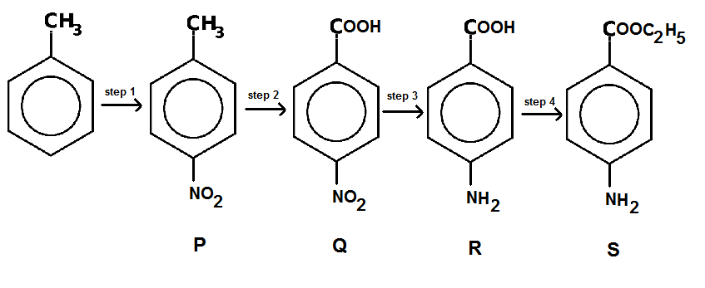
(a) In step 1, methylbenzene is treated with a mixture of two reagents.
i. Identify the two reagents and write an equation showing the formation of the reactive species involved.
.....................................................................................................................................................................................
...............................................................................................................................................................................[3]
ii. State the type of reaction taking place.
................................................................................................................................................................................[1]
iii. Name and draw the mechanism.

................................................................................................................................................................................[3]
(b) The product obtained from step 1 is a liquid and contains compound P, contaminated with other isomers. When pure, compound P is a crystalline solid, with melting point 51ºC.
i. Describe briefly how chromatography could be used to obtain a pure sample of crystalline P from 5g of the impure liquid mixture.
.....................................................................................................................................................................................
.....................................................................................................................................................................................
.....................................................................................................................................................................................
................................................................................................................................................................................[5]
(c) Name the type of reaction occurring in step 2.
................................................................................................................................................................................[1]
(d) Name the type of reaction taking place in step 3 and give a suitable reagent or mixture of reagents for this conversion.
.....................................................................................................................................................................................
................................................................................................................................................................................[3]
(e) Write an equation to represent the reaction between R and hydrochloric acid.
................................................................................................................................................................................[1]
(f) i. Name the type of reaction occurring in step 4.
................................................................................................................................................................................[1]
ii. Identify the reagents needed for the conversion.
................................................................................................................................................................................[2]
ii. Give the systematic name of compound S.
................................................................................................................................................................................[1]
[Total: 21]
3. (a) Write an equation to illustrate how the primary amine RNH₂ functions as a BrØnsted-Lowry base.
................................................................................................................................................................................[1]
(b) Explain why ethylamine is a stronger base than ammonia whereas phenylamine is less basic than ammonia.
.....................................................................................................................................................................................
.....................................................................................................................................................................................
.....................................................................................................................................................................................
................................................................................................................................................................................[4]
(c) Amines such as propylamine can be made from halogenalkanes.
i. Name the type of reaction involved.
................................................................................................................................................................................[1]

ii. Name the reagents used for the conversion of 1-bromopropane into propylamine.
................................................................................................................................................................................[1]
iii. Write an equation for the reaction and draw the mechanism.

...............................................................................................................................................................................[3]
iv. When there is an excess of the halogenoalkane, further substitution may occur. Use displayed formulae to show how this occurs.

................................................................................................................................................................................[2]
(d) i. Give the structure and name the type of compound formed when R₂NH is heated with a large excess of chloromethane.

................................................................................................................................................................................[2]
ii. Give one use of the product obtained when R is a very long alkyl group.
................................................................................................................................................................................[1]
[Total: 15]
4. A mixture of two organic liquids could not be separated efficiently using fractional distillation. Use of a different laboratory technique permitted the isolation of compound X (boiling point = 202ºC) and compound Y (boiling point = 205ºC).
The mass spectrum of compound X has the molecular ion peak at m/z = 120 together with two major peaks at m/z = 77 and m/z = 105. A dominant peak appears in the infra-red spectrum of X at 1690cm⁻¹. One peak in the ¹H NMR spectrum of X is a three-proton singlet at δ 2.60 ppm and one of the peaks present in the ¹³C NMR spectrum has a strong signal at δ 198 ppm. Compound X remains unchanged when heated with acidified potassium dichromate(VI) solution.
The mass spectrum of compound Y has the molecular ion peak at m/z = 108 and a major peak at m/z = 77. An intense peak appears in the infra-red spectrum of Y at 3352cm⁻¹. One peak in the ¹H NMR spectrum of Y is a two-proton singlet at δ 4.50 ppm. Compound Y is oxidised to benzenecarboxylic acid when heated with acidified potassium dichromate (VI) solution.
(a) Suggest which technique was used to separate compounds X and Y.
................................................................................................................................................................................[1]
(b) What conclusions can be drawn from the fact that both X and Y have a fragment ion at m/z = 77 in their mass spectra?
.....................................................................................................................................................................................
................................................................................................................................................................................[2]
(c) By reference to the various m/z values provided, deduce the structure of the fragment ion appearing at m/z = 105 in the mass spectrum of compound X.
.....................................................................................................................................................................................
................................................................................................................................................................................[2]
(d) For compound X, identify the groups associated with the following peaks:
i. 1690cm⁻¹ in the infra-red spectrum
.....................................................................................................................................................................................
ii. δ 2.60 ppm in the ¹H NMR spectrum
.....................................................................................................................................................................................
iii. δ 198 ppm in the ¹³C NMR spectrum
................................................................................................................................................................................[3]
(e) Deduce the structure of compound X.
.....................................................................................................................................................................................
.....................................................................................................................................................................................
................................................................................................................................................................................[1]
(f) For compound Y, identify the groups associated with the following peaks:
i. 3352cm⁻¹ in the infra-red spectrum
.....................................................................................................................................................................................
ii. δ 4.50 ppm in the ¹H NMR spectrum
................................................................................................................................................................................[2]
(g) Deduce the structure of compound Y.
................................................................................................................................................................................[1]
(h) Explain how the behaviour of compounds X and Y towards acidified potassium dichromate (VI) solution relates to the structures of these compounds.
.....................................................................................................................................................................................
................................................................................................................................................................................[1]
[Total: 13]

