Alkanes
A___________ are s___________ h______________. They consist of the elements c__________ and h___________, and all the bonds between the Carbon atoms are s__________ bonds. They have the general formula _____________. Since all Alkanes are similar in structure and properties, they are called a h______________ s_____________.
The structure of an alkane, as with all hydrocarbons, can be represented with a
  - A 3D diagram, with all the atoms and bonds shown, modelled in 3 dimensions.
  - Displayed Formula, with all the atoms and bonds shown.
  - Skeletal Formula, with only the bonds between the Carbon atoms shown.
  - Shortened Structural Formula, a linear form where all the atoms are shown but no bonds.

Branched Alkanes and Cycloalkanes
Alkanes can be l________ s____________ c_____________ of carbon atoms bonded with each other and hydrogen, but they can also come in different shapes. B______________ can occur, as can the formation of c______________ structures. This is called i________________.
B____________ a__________ occur when a straight chain alkane forms replaces one of its hydrogen atoms with an a_________ group (an alkane which has similarly lost a hydrogen on the end carbon), forming a b_____________. Branching can happen in many different ways and means that a variety of possible structures can exist for one m________________ f____________. Branched Alkanes may have the prefix 'iso'.
C________ a___________ have the general formula _____________ and consist of C__________ atoms bonded in a c___________ structure. They are name with the prefix 'c________', for example cyclohexane.
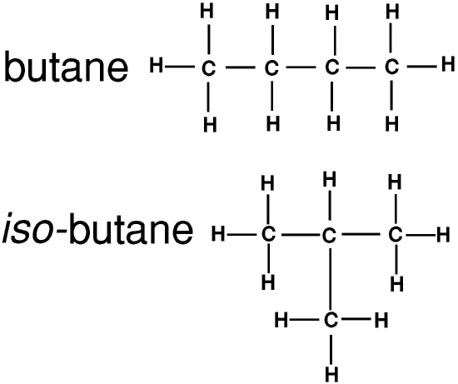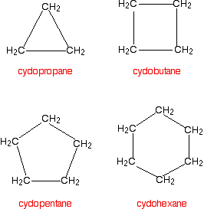

Reactions of Alkanes
Since a________ are s__________ h__________, they do not readily react. However, they can be made to react under certain conditions, so give useful products or energy output. Alkanes will react with o_________ if they are given sufficient a___________ e_______. This will result in a highly e________ reaction, producing c______ d_____ and w_____, which makes alkanes very useful as fuels.

When Alkanes C₄-C₆ are heated to 150°C with a platinum of aluminium o________ c________, isomerism occurs. The reaction produces branched a_________, and so is useful in improving octane number. Reforming is the process of increasing the amount of c____________ and Hydrocarbons containing b________ rings, to improve octane number. This is done with alkanes in the naphtha fraction (C₆-C₁₀) at 500°C with a p__________ or a_________ oxide catalyst. Hydrogen is recycled through the mixture to reduce 'coking'.

C________ is the process of breaking longer chained a__________ down into smaller alkanes and alkenes, sometimes for p_________ manufacture, and sometimes to improve octane number. Steak cracking involves heating alkanes from the naphtha and kerosene fractions (C₆-C₁₆) to 900°C without a catalyst and using steam as a diluent to reduce 'coking'. This is used in the manufacture of Polymers. C_________ cracking takes feedstock from longer chained alkanes in the gas oil fraction (C₁₄-C₂₀) and heating to 500°C with a Z________. This can produce branched and cyclic h___________ and is used to improve octane number.

