Amines
Amines are classified as primary, secondary, or tertiary based upon the number of carbon-containing groups that are attached to the nitrogen atom. Those amine compounds that have only one group attached to the nitrogen atom are primary, while those with two or three groups attached to the nitrogen atom are secondary and tertiary, respectively.
Nomenclature of Amines
In the IUPAC System, apply the following rules to name amines:
- Pick out the longest continuous chain of carbon atoms. The parent name comes from the alkane of the same number of carbons.
- Change the -e of the alkane to “amine.”
- Locate and name any substituents, keeping in mind that the chain is numbered away from the amine group. Substituents, which are attached to the nitrogen atom instead of the carbon of the chain are designated by a capital N.
1. Primary amines R-NH₂
a. Primary amines can be named by replacing the -e of the parent group with the word amine. The –NH₂ group can also be named as a substituent using the group name, amino. An amine can also be named by naming the parent group followed by a space and the word amine.
2-propanamine, 2-aminopropane or 2-propyl amine

- Try to name the following compounds using these conventions…

- Try to draw structures for the following compounds…
  - 3-aminopentane

  - t-butyl amine

A common name that you should know is...
- Try to draw structures for the following compounds…
  - 4-methoxyaniline

2. Secondary amines R₂NH
a. Secondary amines can be named by replacing the -e of the parent group with the word amine and then using an upper case N to designate that the second alkyl group is on the nitrogen atom. The –NH₂ group can still be named as a substituent using the group name, amino.
N-methyl-1-propanamine, N-methyl-1-aminopropane, or methyl 1-propyl amine
- Try to name the following compound using these conventions…

- Try to draw a structure for the following compound…N-methyl-3-aminopentane
3. Tertiary amines R₃N
Tertiary amines can be named in the same way as secondary amines.
- Try to name the following compound using these conventions…

- Try to draw a structure for the following compound…N,N-dimethylaniline

4. Quaternary ammonium salts R₄N⁺X⁻
Name these compounds as the ammonium salts. e.g. (CH₃)₄N⁺Br⁻ tetramethyl ammonium bromide.

Basicity of amines
Amines are basic because they possess a pair of unshared electrons, which they can share with other atoms. These unshared electrons create an electron density around the nitrogen atom. The greater the electron density, the more basic the molecule. Groups that donate or supply electrons will increase the basicity of amines while groups that decrease the electron density around the nitrogen decrease the basicity of the molecule. For alkyl halides in the gas phase, the order of base strength is given below:
(CH₃)₃ N > (CH₃)₂NH > CH₃NH₂ > NH₃
most | least
basic | basic

However, in aqueous solutions, the order of basicity changes.
(CH₃)₂ NH > CH₃NH₂ > (CH₃)₃N > NH₃
most | least
basic | basic

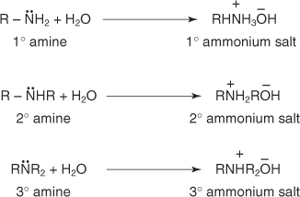
The differences in the basicity order in the gas phase and aqueous solutions are the result of solvation effects. Amines in water solution exist as ammonium ions.
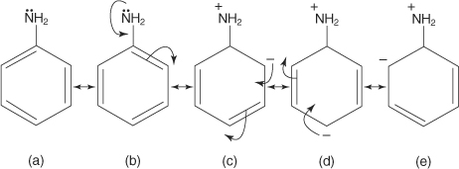
In water, the ammonium salts of primary and secondary amines undergo solvation effects (due to hydrogen bonding) to a much greater degree than ammonium salts of tertiary amines. These solvation effects increase the electron density on the amine nitrogen to a greater degree than the inductive effect of alkyl groups.
Arylamines are weaker bases than cyclohexylamines because of resonance. Aniline, a typical arylamine, exhibits the resonance structures shown below. As structures b through e show, delocalization of the unshared electron pair occurs throughout the ring, making these electrons less available for reaction. As a result of this electron delocalization, the molecule becomes less basic.
Exam Question
Compare the relative basicities of ethylamine and phenylamine and explain why this is so.

