Tasks
These tasks should take 3 hours to complete: Two hours of lesson time and one hour of homework. Completed tasks should be handed in to the Prep room on Friday at the end of period 5.

Task 1: Read through the information sheets about NMR and MRI and make your own notes.

Task 2: Answer the questions.
- Ethanol is commonly used as a solvent in chemistry. Why isn’t it used to prepare a sample for an NMR spectrometer?

- The NMR spectrum of butane is shown. Relate this spectrum to the structure of the compound.
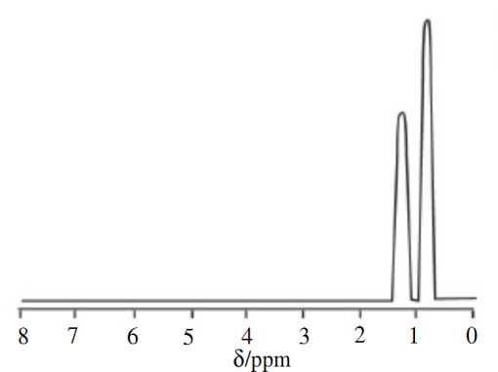

- The following NMR spectra are of the isomers propanal and propanone. Show which spectrum belongs to each compound.

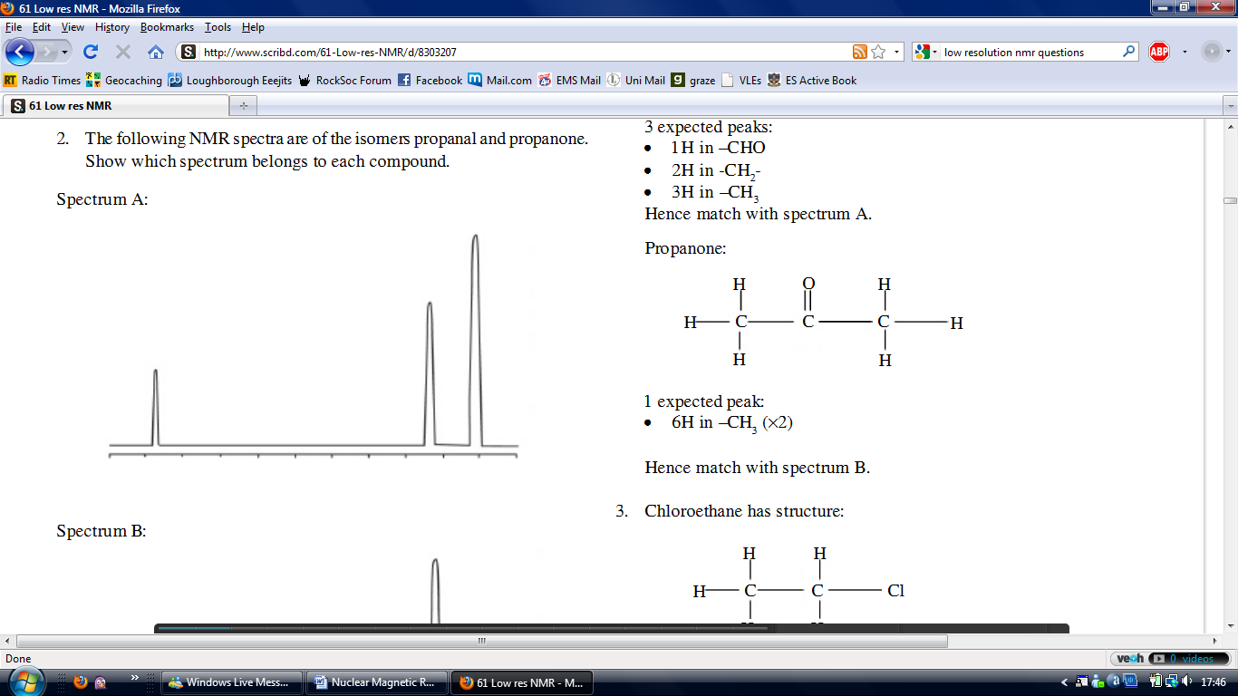
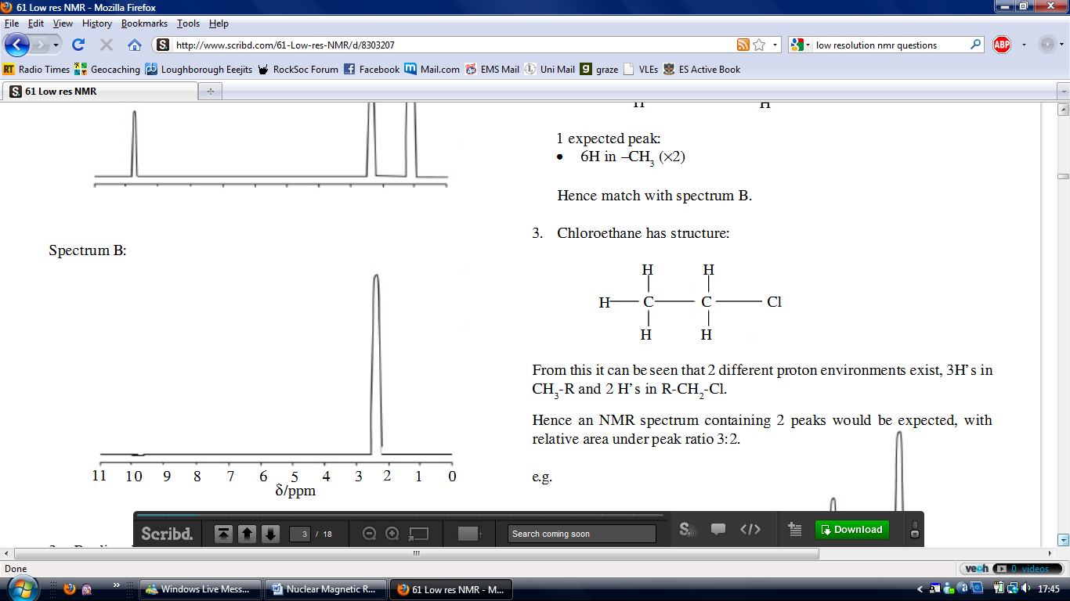

- Predict the appearance of the NMR spectrum of chloroethane.

Task 3: Write a report to describe and explain how MRI works. Include advantages and disadvantages of using MRI as a technique. There is a good source of information on the www.howstuffworks.com website. Continue onto another sheet if necessary.
.............................................................................................................................................................................................................................................................................................................................................................................................................................................................................................................................................................................................................................................................................................................................................................................................................................................................................................................................................................................................................................................................................................................................................................................................................................................................................................................................................................................................................................................................................................................................................................................................................................................................................................................................................................................................................................................................................................................................................................................................................................................................................................................................................................................................................................................................................................................................................................................................................................................................................................................................................................................................................................................................................................................................................................................................................................................................................................................................................................................................................................................................................................................................................................................................................................................................................................................................................................................................................................................................................................................................................................................................................................................................................................................................................................................................................................................................................................................................................................................................................................................................................................................................................................................................................................................................................................................................................................................................................................................................................................................................................. ................................................................................................................................................................................................................................................................................................................................................................................................................................................................................................................................................................................................................................................................................................................................................................................................................................................................................................................................................................................................................................................................................................................................................................................................................................................................................................................................................................................................................................................................................................................................................................................................................................................................................................................................................................................................................................................................................................................................................................................................................................................................................................................................................................................................................................................................................................................................................................................................................................................................................................................................................................................................................................................................................................................................................................................................................................................................................................................................................................................................................................................................................................................................................................................................................................................................................................................................................................................................................................................................................................................................................................................................................................................................................................................................................................................................................................................................................................................................................................................................................................................................................................................
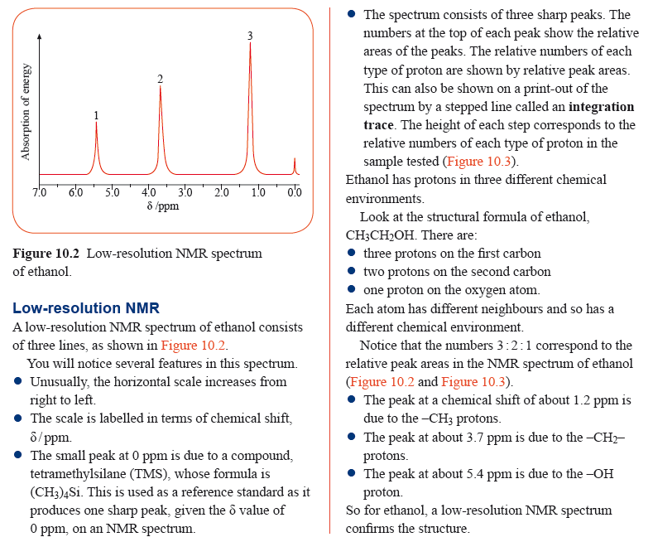
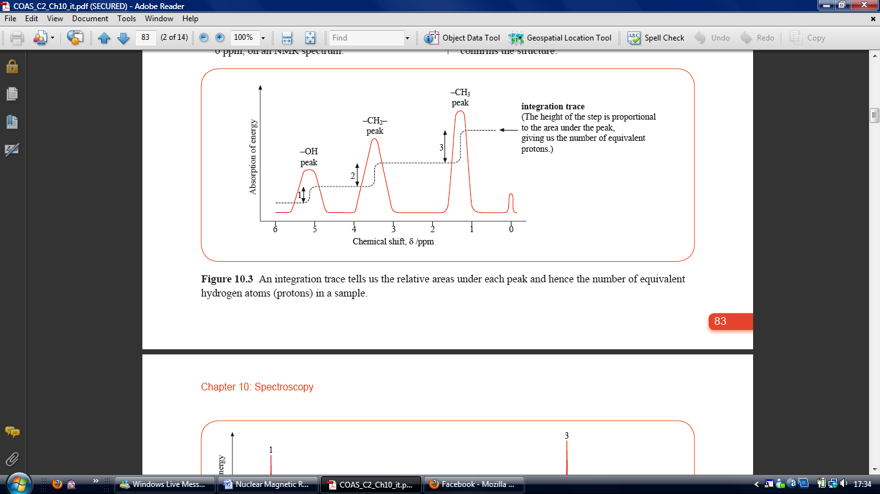
Low Resolution NMR Foundation Information Sheet
Nuclear Magnetic Resonance Higher Information Sheet
Nuclear magnetic resonance (NMR) spectroscopy gives the most information of the spectroscopic
analyses, with regard to the positions and numbers of protons (hydrogen atoms) in the molecule:

- Nuclei spin, and thus create a magnetic field around them, as they are charged. If they are placed within a magnetic field, they all line up either in the same direction (lower energy) or in the opposite direction (higher energy) to the magnetic field. The very small energy gap between these states corresponds to radio frequency waves. Normally a fixed magnetic field is used, and the frequency of applied radio waves (causing resonance) is modified, in order to scan the sample and detect the effects.

- The chemical shift, δ, is measured in ppm (parts per million), and depends upon the amount of shielding of the protons by electrons – the more shielding, the higher the field strength needed for resonance, and the lower the δ value.

- The amount of shielding depends upon the environment of the protons – if they are next to an electronegative atom (e.g. in COOH) then there will be deshielding and a high δ value (downfield), whereas if they are next to an atom with low electronegativity (e.g. in CH₃) there will be more shielding and a lower δ value (upfield).

- The δ value is determined as relative to a standard of TMS (tetramethylsilane – Si(CH₃)₄):
i. This gives a strong signal due to 12 protons in the same environment.
ii. Si is less electronegative than carbon, so the signal is upfield of other organic molecules (δ is defined as 0.0ppm).
iii. It is inert and non-toxic, cheap, and is volatile (can be evaporated afterwards).

- The area under each peak on the NMR spectrum is proportional to the number of protons it represents (in the same environment), and this ratio is given by the integration curve.

- A high resolution NMR spectrum is able to show splitting of individual peaks, due to being adjacent to other protons in a different environment:
i. The number of splits is n + 1 where the number of adjacent protons is n (n + 1 rule). The splitting pattern is given by the (n + 1)^{th} line of Pascal’s triangle.
ii. A triplet (1:2:1) indicates that the protons are adjacent to a CH₂ group.
iii. A quartet (1:3:3:1) indicated that the protons are adjacent to a CH₃ group.
iv. An ethyl group (CH₂CH₃) is indicated by a triplet and a quartet, with integration curves in a 3:2 ratio.
v. If there is no splitting, then the protons are not adjacent to any different protons (a singlet) – e.g. the H in an OH group.
vi. If the protons are next to two different types of proton, then there will be splitting of the splitting pattern (e.g. a quartet of triplets).
vii. The splitting of peaks is called the coupling effect.
Magnetic Resonance Imaging


